Name: __________________

School of Secondary-Tertiary Studies

Unit Standard 12416

Task two: ALAC advertisements

Explore language and think critically about static images

3 Credits

People credited with this unit standard are able to explore language and think critically aboutstatic images.

Task two of two. You are required to:

Critically analyse **two** visual texts, by identifying, and giving examples of the following.

1. The main idea or message
2. The significance of the main idea (this may include the target audience and how you can tell)
3. Visual language features and their effects (these may include choice of colour, lettering style, symbolism)
4. Verbal language features and their effects (these may include choice of words, figures of speech, grammatical structures, pun, repetition, alliteration, onomatopoeia)
5. An aspect of the organisation of the text and its effect (this may include layout, balance or contrast)

This is the second of two assessments for 12416.

The resources you need are attached.

The assessment is to be completed within one hour during class under test conditions.

You will have one opportunity to resubmit the assessment.

You will be assessed on the following criteria

|  |  |  |  |
| --- | --- | --- | --- |
|  |  | N | A |
| 1.1 | At least one main idea or message is identified with reference to at least one relevant section of the text. |  |  |
| 1.2 | The significance of a main idea or message is explained with reference to at least one relevant section of the text.  Range: significance refers to social, historical, cultural, physical, political, or personal contexts. |  |  |
| 1.3 | Three examples of language features are identified using appropriate terminology, and each example is described in terms of its effect.  Range: at least one visual and one verbal feature;  visual language features could include - use of colour, style of lettering, symbolism;  verbal language features could include - words used, figures of speech, grammatical structures. |  |  |
| 1.4 | An aspect of the organisation of the text is identified and explained with reference to at least one relevant section of the text.  Range: organisation could include - layout, balance of visual and verbal text, contrast. |  |  |

**Images borrowed from Alcohol Advisory Council (ALAC)**

**‘It’s not the drinking, it’s how we’re drinking’ campaign.**

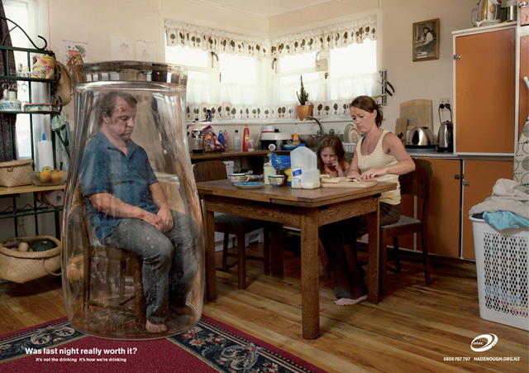

Was last night really worth it? alac

It’s not the drinking, it’s how we’re drinking 0800 787 797 HADENOUGH.ORG.NZ

**Image B**



*ALCOHOL ADVISORY COUNCIL OF NEW ZEALAND* alac *Kaunihera Whakatupato Waipiro o Aotearoa*

Student Name: ……………………………………………………….

Teacher: …………………………………………………………………

Date: ……………………………………..

Assessment Task for Unit Standard 12416

Explore language and think critically about static images

**Look carefully at the two images. They are both advertisements produced by ALAC – The Alcohol Advisory Council of New Zealand.**

**For any of the following questions you may answer on either of the images**

1. What do you think is the meaning of the slogan; **“It’s not the drinking, it’s how we’re drinking”?** ……………………………………………………………………………………………………………………………………………………………………………………………………………………………………………………………………………………………………………………………………………………………………………………………………………………………………………..

1.1

1. What does the image say about alcohol’s impact on families? What shows you this in the image?

………………………………………………………………………………………………………………………………………………………………………………………………………………………………………………………………………………………………………………………………………………………………………………………………………………………………………………

1. Explain the impact alcohol has had on the father in the image. Refer to the image to support your views.

………………………………………………………………………………………………………………………………………………

………………………………………………………………………………………………………………………………………………………………………………………………………………………………………………………………………………………………

1.2

3. Complete the following chart

|  |  |  |  |
| --- | --- | --- | --- |
|  | Technique | Example | Effect/Purpose |
| E.g. Visual feature | Dominant Image | The father is sitting up in an upturned beer glass which is oversized. The image is slightly off centre distorted and slightly blurry. | This emphasises his isolation from his family and the world around him. He is also trapped and uncomfortable. The reader is drawn to the picture because it is unusual The audience immediately recognise that he has been drinking and is now suffering. |
| 1. Visual feature | Symbolism |  |  |
| 1. Visual feature | Location/Setting |  |  |
| 1. Verbal feature | Parallel structures / Repetition |  |  |
| 1. Verbal feature |  | Was last night really worth it? | 1.3 |

4. Complete the following chart

|  |  |  |  |
| --- | --- | --- | --- |
|  | Aspect | Example | Effect/Purpose |
| E.g. Organisational aspect | Layout | The alac logo is in the bottom right corner | The bottom right corner is the place where the eye naturally rests. This emphasises to the audience that the message |
| Organisational aspect | Contrast |  | 1.4 |