Name : __________________
School of Secondary-Tertiary Studies
Unit Standard 12416
Task One: 50 Cent Poster
Explore language and think critically about static images
3 Credits

People credited with this unit standard are able to explore language and think critically about static images.
Task one of two: You are required to:
Critically analyse two visual texts, by identifying, and giving examples of the following.
- The main idea or message
- The significance of the main idea (this may include the target audience and how you can tell)
- Visual language features and their effects (these may include choice of colour, lettering style, symbolism)
- Verbal language features and their effects (these may include choice of words, figures of speech, grammatical structures, pun, repetition, alliteration, onomatopoeia)
- An aspect of the organisation of the text and its effect (this may include layout, balance or contrast)

This is the first of two assessments for US 12416.
The resources you need are attached.
The assessment is to be completed within one hour during class under test conditions.
You will have one opportunity to resubmit the assessment.
You will be assessed on the following criteria
 |  | N | A
1.1 | At least one main idea or message is identified with reference to at least one relevant section of the text.
1.2 | The significance of a main idea or message is explained with reference to at least one relevant section of the text.  Range: significance refers to social, historical, cultural, physical, political, or personal contexts.
1.3 | Three examples of language features are identified using appropriate terminology, and each example is described in terms of its effect.  Range: at least one visual and one verbal feature;  visual language features could include - use of colour, style of lettering, symbolism;  verbal language features could include - words used, figures of speech, grammatical structures.
1.4 | An aspect of the organisation of the text is identified and explained with reference to at least one relevant section of the text.  Range: organisation could include - layout, balance of visual and verbal text, contrast.

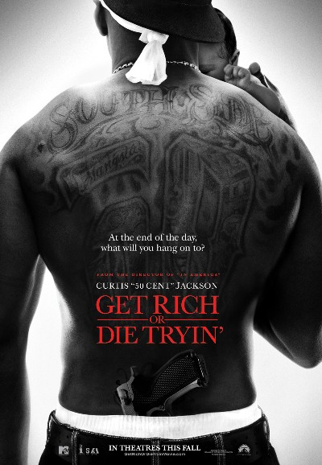

Student Name: ……………………………………………………….
Teacher: …………………………………………………………………
Date: ……………………………………..

Assessment Task for Unit Standard 12416
Explore language and think critically about static images

Look carefully at the image. It is an advertisement for the 50 Cent Movie, ‘Get Rich or Die Tryin’ ’.

- What do you think is the meaning of the question; “At the end of the day, what will you hang on to?” ……………………………………………………………………………………………………………………………………………………………………………………………………………………………………………………………………………………………………………………………………………………………………………………………………………………………………………..
- What does the visual image tell you about the character’s lifestyle? ………………………………………………………………………………………………………………………………………………………………………………………………………………………………………………………………………………………………………………………………………………………………………………………………………………………………………………
1.1

- What does the image say about doing what you want to in this life? What shows you this in the image?
………………………………………………………………………………………………………………………………………………………………………………………………………………………………………………………………………………………………………………………………………………………………………………………………………………………………………………
- From the image, we know he is an adult because he has a baby with him, so how does this poster show that the film is meant to appeal to teenagers? Refer to the image to support your views. ………………………………………………………………………………………………………………………………………………………………………………………………………………………………………………………………………………………………………………………………………………………………………………………………………………………………………………
- What does the image say about the issues facing many young African Americans and the communities in which they live?
………………………………………………………………………………………………………………………………………………
……………………………………………………………………………………………………………………………………………………………………………………………………………………………………………………………………………………………
1.2

6. Complete the following chart
 | Technique | Example | Effect/Purpose
E.g. Visual feature | Symbolism | The white doo rag around his head under the backwards cap. | Both the doo rag and the backwards cap are symbols of urban street and gangsta culture. Together they emphasise that the subject is trendy, tough and doing things the way he wants.
- Visual feature | Symbolism
- Visual feature |  | The tattoo across his shoulder blades is written in tribal script.
- Verbal feature |  | GET RICH OR DIE TRYIN’
- Verbal feature | Questioning |  | 1.3

7. Complete the following chart
 | Aspect | Example | Effect/Purpose
E.g. Organisational aspect | Layout | The dominant image is a photo from behind of a man holding a baby, placed clearly in the centre of the page. | Our eyes are drawn to the image and see it as a whole before noticing the details within it. It is an interesting photograph.
Organisational aspect | Contrast |  | 1.4

